**Abstract Factory**

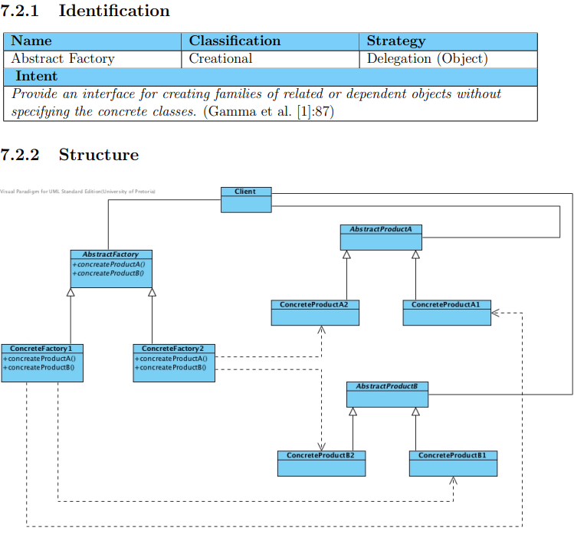

* Participants
  + AbstractFactory
  + ConcreteFactory
  + AbstractProduct
  + ConcreteProduct
  + Client
* Factory method vs abstract factory
  + Factory method: one-to-one relationship
  + Abstract factory: one-to-many relationship
* Related patterns
  + Factory Method or Prototype
  + Template Method
  + Singleton